MDHI Board Meeting 10/4/2022

In attendance: Mike Malloy, Erin Ralston, Carla Respects Nothing, Jennifer Biess, Mateo Parsons, Clayton Gonzalez, Joey Willet, Jess Dianni, Brendan Clark, Adam Kendall, John Feeney-Coyle
Staff: Jackie Hernandez, Jamie Rife, Kyla Moe
Administrative:
I. Welcome (Mike M.): 5:30 – 5:32
II. Land and Cultural Acknowledgement 5:32 – 5:35
- The meeting began at 5:36 pm
- Erin Ralston opened the meeting by reading the Land and Cultural Acknowledgement
III. Consent Agenda - Vote (Mike M.): 5:35 – 5:40
∼ September 2022 Board Minutes
- Mike asked if there were any questions about the consent agenda
- Joey moved to approve the consent agenda and Carla seconded
  - The board voted to approve the minutes with the exception of Jennifer Biess who abstained
- Adam Kendall joined the meeting
Topics:
I. Acknowledging Carla’s Service to Our Community 5:40 – 5:50
- Mike shared his gratitude for Carla’s service on the board and thanked her for all her hard work
- Jennifer shared her gratitude for working on the board and the continuum activities board
- Joey thanked Carla for her genuine care and concern for this topic and her authenticity
- Brendan shared how much he appreciated Carla’s passion for the work
- Mateo also shared how much he appreciates Carla and how consistent she is, always showing up for the community
- Carla thanked everyone
John Feeney Coyle joined the call
II. Governance 5:50 – 6:00 – Joey
∼ Committee Assignments
- Joey reviewed the committee assignments and shared the following committee assignments
- 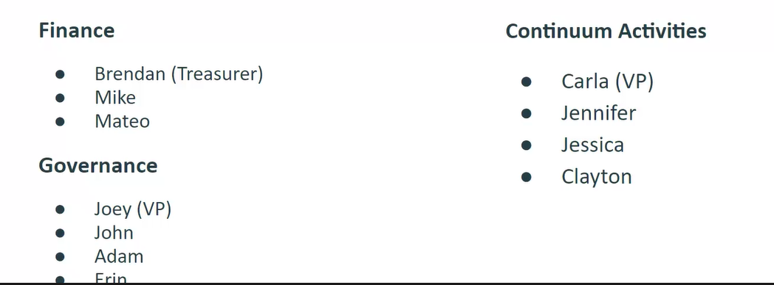
- The two board members joining in January will be good fits for finance and governance to continue to balance
- The Continuum Activities may need to have members in the future
- Joey asked for discussion around the committees and the committee structure
  - JFC mentioned that the YALC member may be a good fit for the Continuum Activities
  - Joey also mentioned that people may want to consider joining more than one committee; they can let him know if they would like to
  - The only edit was removing Mike from the Finance Committee
  - The suggestion was made to have staff assigned to the CA committee

III. ESG Signatory Authority to Executive Director 6:00 – 6:05
- Adam made the motion, Joey seconded
- The motion passed unanimously, no abstentions
-We move to approve that Dr. Jamie Rife has full signatory authority in regard to all contracts and corresponding documents associated with agreements entered into by Metro Denver Homeless Initiative and Colorado Department of Local Affairs, Division of Housing for the Emergency Solutions Grants Program.
IV. Policy Governance Manual 6:05 – 6:50
- Section 2.9 Board Size, Nominations, etc.
- Terms being changed or remaining the same
- Adam asked if this was enough time
- John felt the two, two-year terms worked well. He also felt it allows for new rotation for new perspectives.
  - He did feel sufficient knowledge can be gained within a year or so and four years allows for a healthy amount of turnover
- Mike also thought four years is a good amount of time
- John added that the chair position might need to be extended with some flexibility
- Jennifer also felt four years felt right; she added that the work the board has done will make it easier to hold continuity
- Adam asked if there was any reason why Charney may have included the suggestion for two-three terms
- Erin added that she has worked in organizations where there were 6 years of service but this was due the weight of onboarding, and she feels that for MDHI 2-2 year terms seems effective
- Brendan added that some boards only meet quarterly whereas MDHI meets monthly and that four years feels right
-Nominating Committee
- The board discussed the idea of forming a Nominating Committee
- John did share there is a lot of work in recruiting board members; and, there is not a lot of other work for the Governance Committee
  - He did suggest having additional board members not on Governance to participate in the board interviews
  - Joey suggested having board representatives from each of the board committees to provide input to the nominating process, he concluded he liked the idea of including additional people in the process
  - John clarified that when it is time for doing interviews if there is interest from others in partaking in the interviews, he would suggest they join
  - Jennifer said this would be Governance managing the process and potentially reaching out to others during the cycle to participate in the interview panel
  - John did say that recruitment should be the responsibility of the entire board
- Erin suggested a working group/subcommittee for nominating – may form a working group as needed to support in the event of an large number of candidates
- Titles for the Executive Committee
VP of Organizational Activities; VP of Continuum Performance; Chair; Treasurer will be the new executive team
Appendix B: Investment Policy
- Brendan did note there needs to be one in place in the case there is another donation such as the Bezos Fund; however, this isn’t something that is happening frequently
- The Finance Committee also discussed the idea of investing money and including this in the policy
- Brendan will be working with Chaz on the Finance Committee to create this; John suggested “An investment policy may be developed by the Finance Committee and adopted by the entire board” if the Finance Committee is unable to come up with one before the next meeting.
  - In the interim, any investments will be brought the board for discussion and approval
- Jamie agreed to incorporate the changes to the next meeting for approval
The meeting went into executive session at 6:31 pm

V. Executive Session 6:50 – 7:30

